Poznawanie innych kultur
Spotkanie z podróżnikiem - Indie

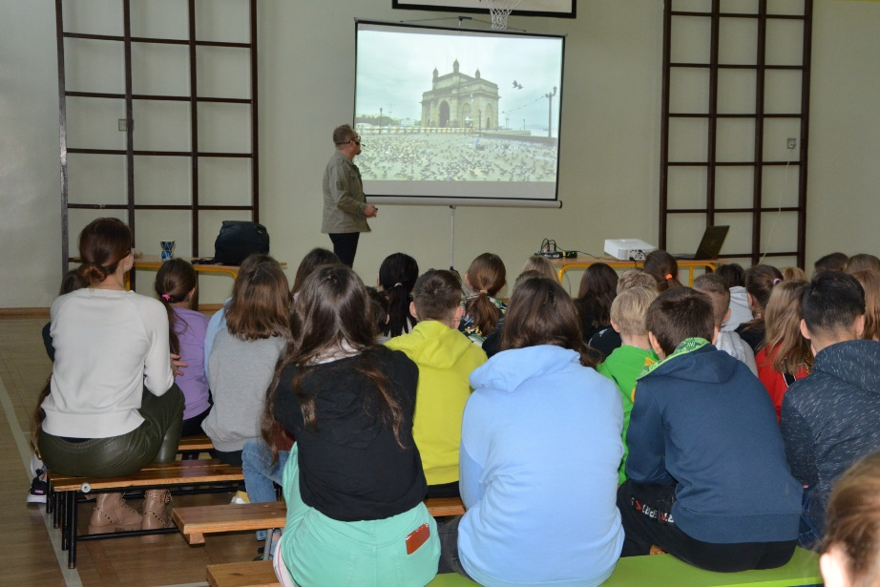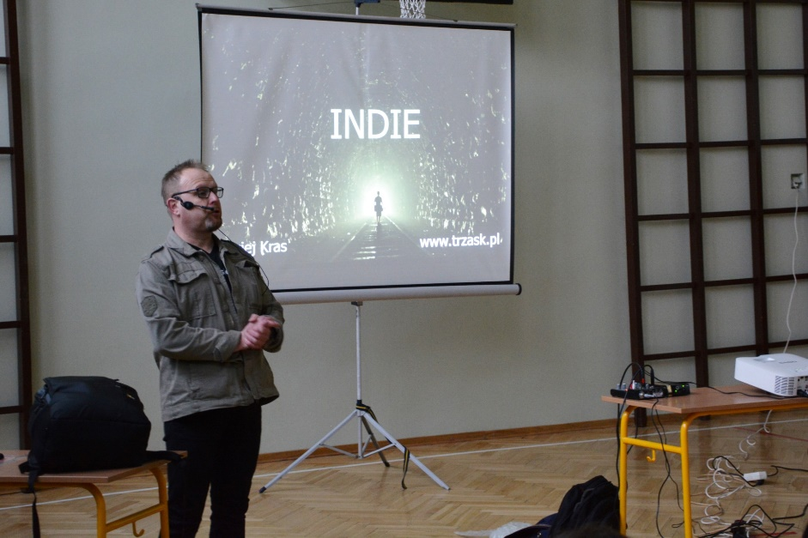

https://spborowa.edupage.org/news/?eqa=d2lkPW5ld3NfTmV3c18xX3AmbmV3c2FyY2hpdmVmPSZvZmZzZXRfbmV3c19OZXdzXzFfcD0yMA%3D%3D#
Walentynkowy Dzień Babci i Dziadka

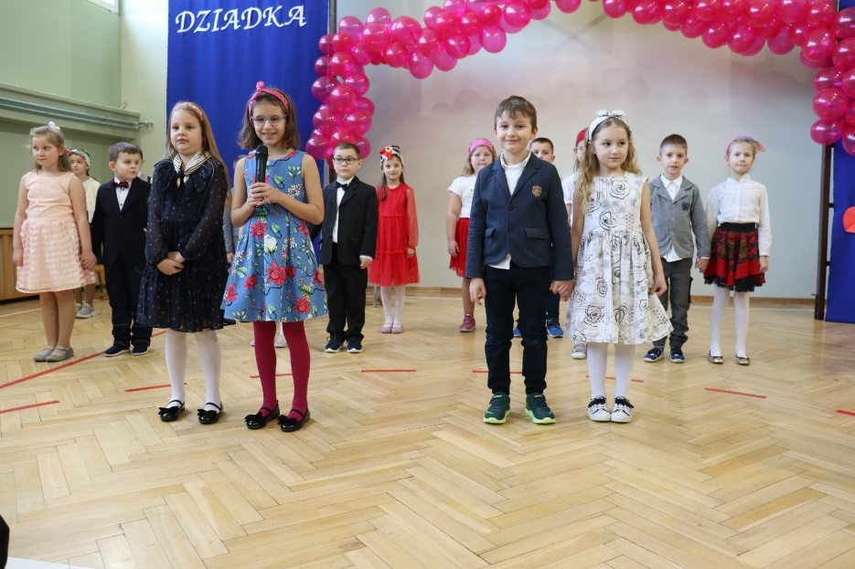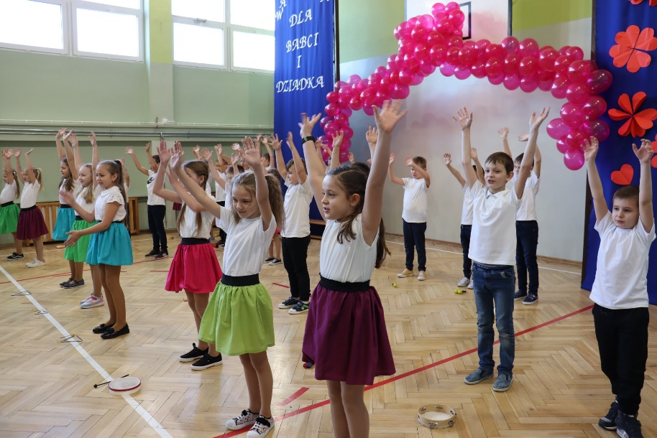

https://spborowa.edupage.org/news/?eqa=d2lkPW5ld3NfTmV3c18xX3AmbmV3c2FyY2hpdmVmPSZvZmZzZXRfbmV3c19OZXdzXzFfcD0yMA%3D%3D#

Walentynki
Dzień walentynkowy w przedszkolu
Zabawa walentynkowo-karnawałowa

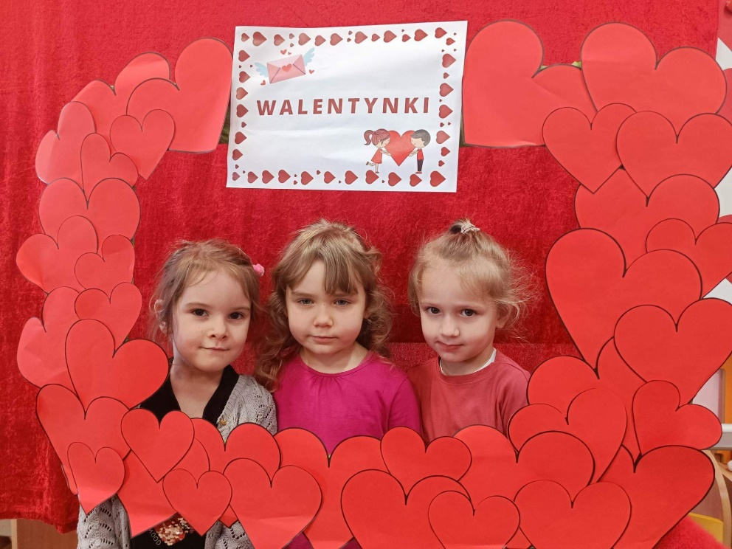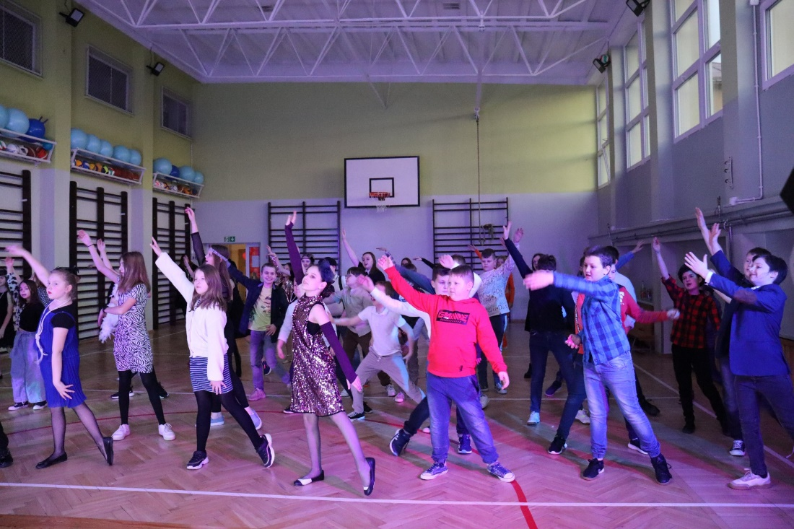
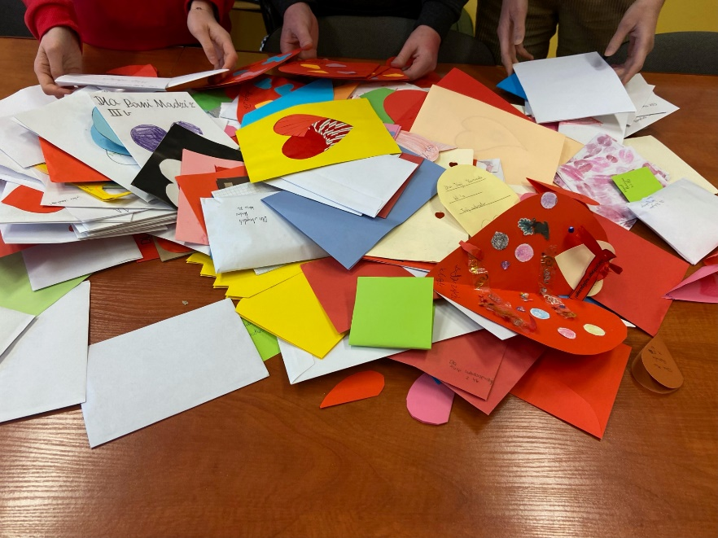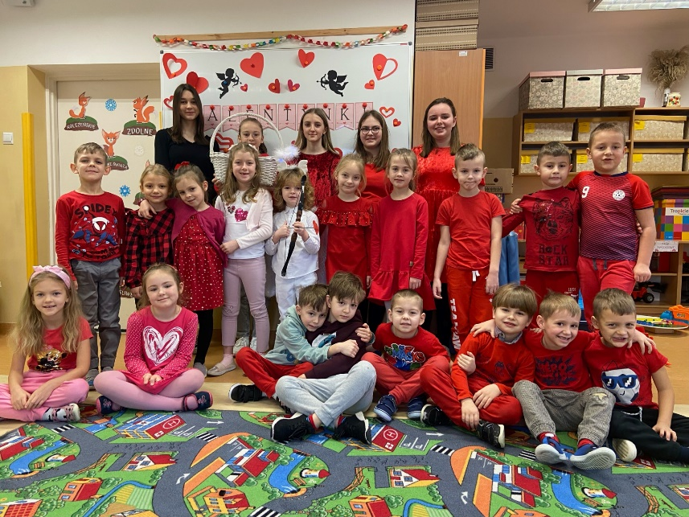

https://spborowa.edupage.org/news/?eqa=d2lkPW5ld3NfTmV3c18xX3AmbmV3c2FyY2hpdmVmPSZvZmZzZXRfbmV3c19OZXdzXzFfcD0yMA%3D%3D#

Uwrażliwienie na potrzeby osób niepełnosprawnych

Projekt społeczno- edukacyjny
"Mój SPE - CJALNY BOHATER"

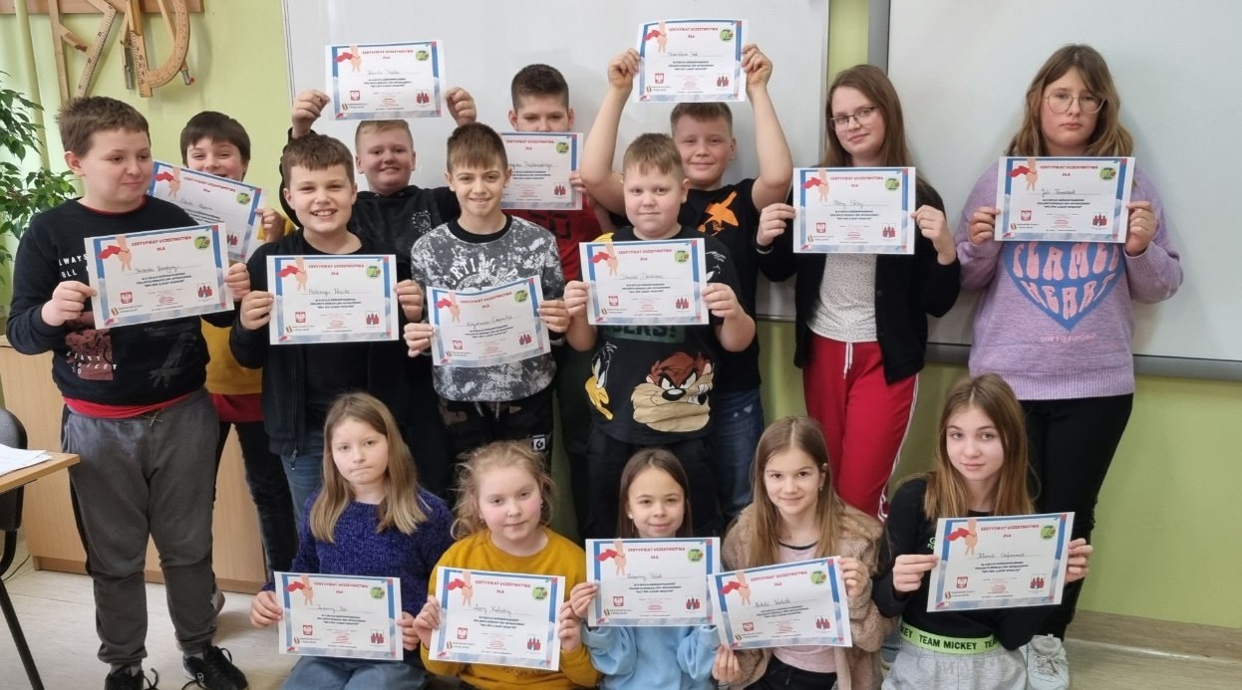

https://spborowa.edupage.org/news/?eqa=d2lkPW5ld3NfTmV3c18xX3AmbmV3c2FyY2hpdmVmPSZvZmZzZXRfbmV3c19OZXdzXzFfcD0yMA%3D%3D#

Międzynarodowy
Dzień Psychologa

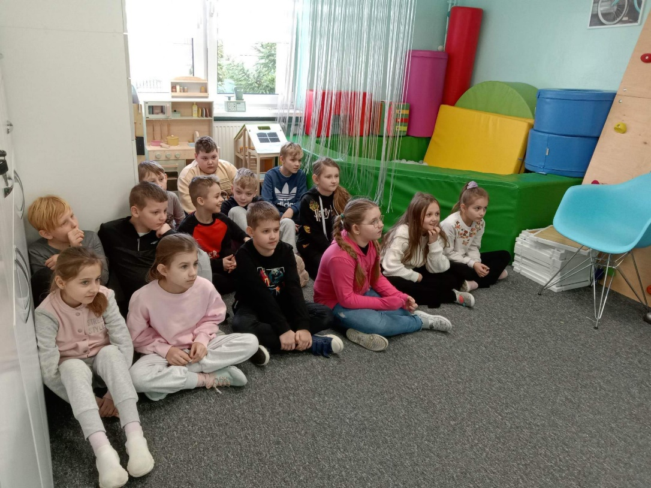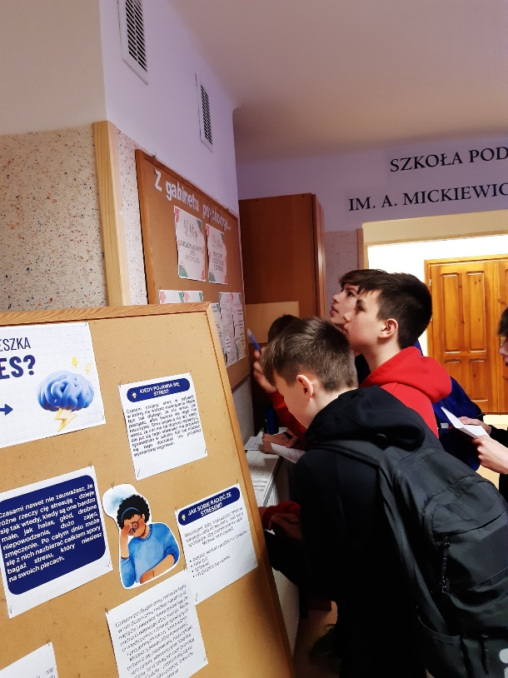

https://spborowa.edupage.org/news/?eqa=d2lkPW5ld3NfTmV3c18xX3AmbmV3c2FyY2hpdmVmPSZvZmZzZXRfbmV3c19OZXdzXzFfcD0w#

Obchody Międzynarodowego Dnia Języka Ojczystego
w klasach IV-VIII

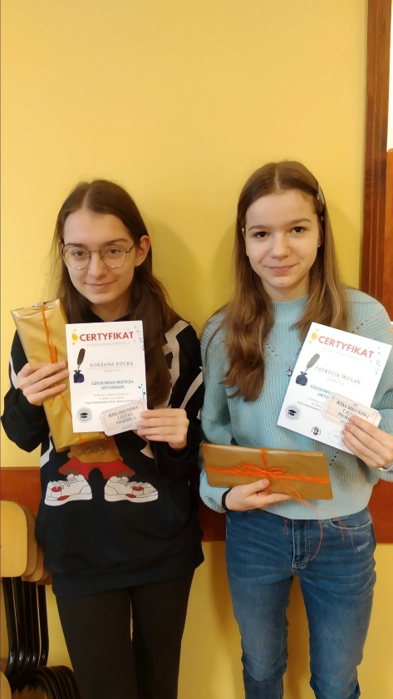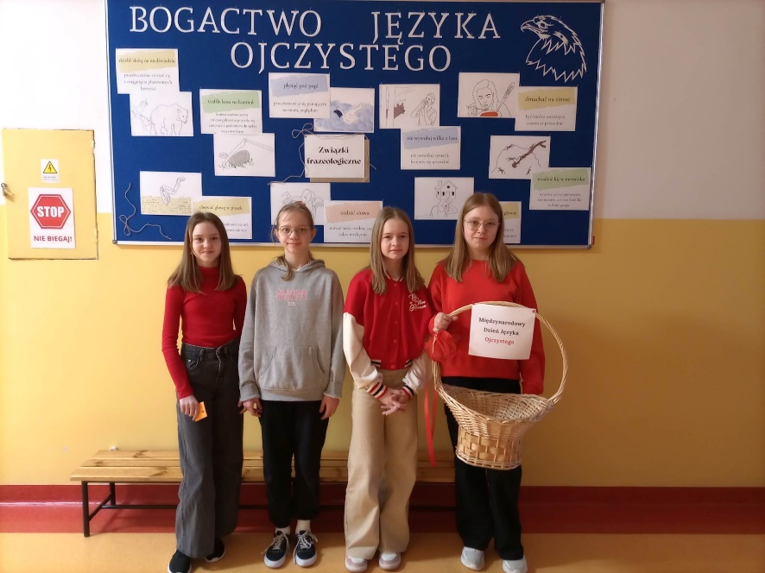
https://spborowa.edupage.org/news/?eqa=bmV3c2FyY2hpdmVmPTIwMjMtMDI%3

