Kształtowanie postaw prospołecznych
NIEPEŁNOSPRAWNOŚĆ
TO DLA MNIE NORMALNA SPRAWA…

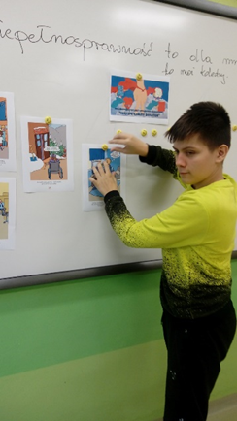
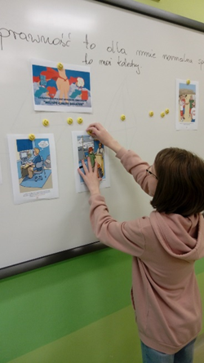

https://spborowa.edupage.org/album/#photos:album:1623
Tworzenie przyjaznego klimatu w szkole
MIKOŁAJ W NASZEJ SZKOLE

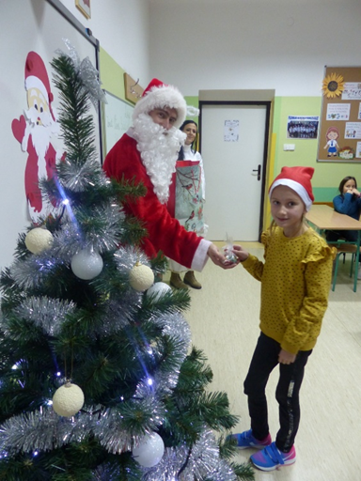
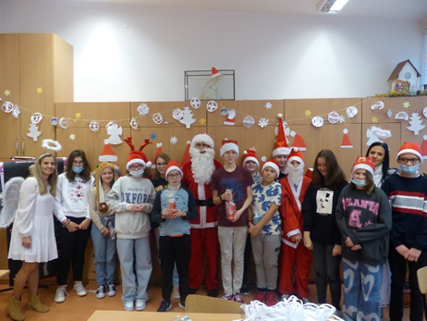

https://spborowa.edupage.org/album/#photos:album:1624

MIKOŁAJ W PRZEDSZKOLU

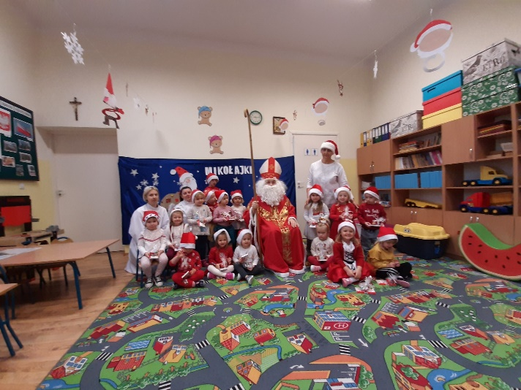
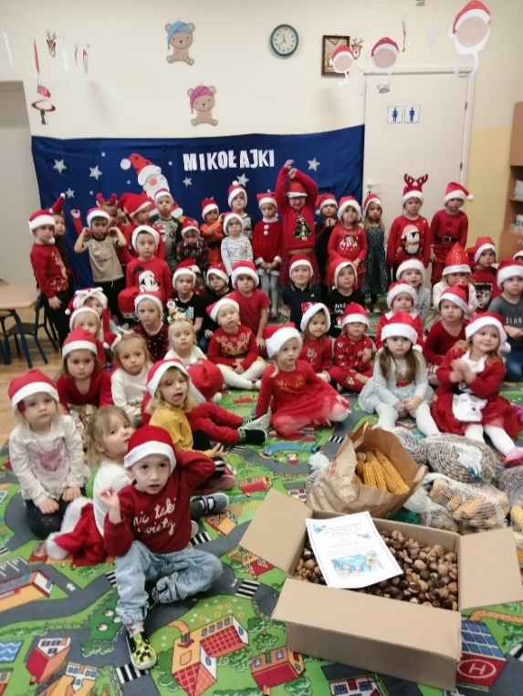

https://spborowa.edupage.org/album/#photos:album:1625

MIKOŁAJ W PRZEDSZKOLU

SPOTKANIE Z MIKOŁAJEM
W LALANDII

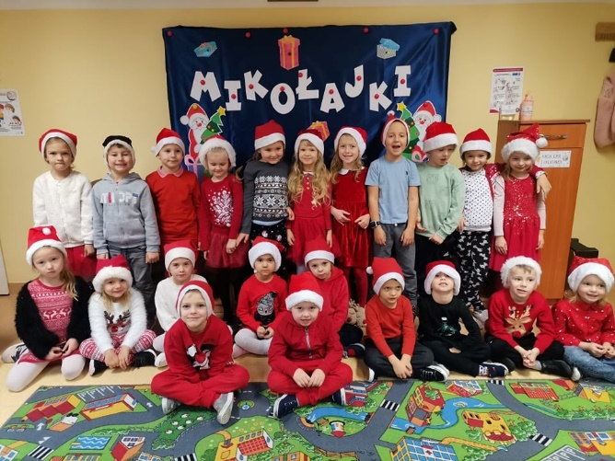
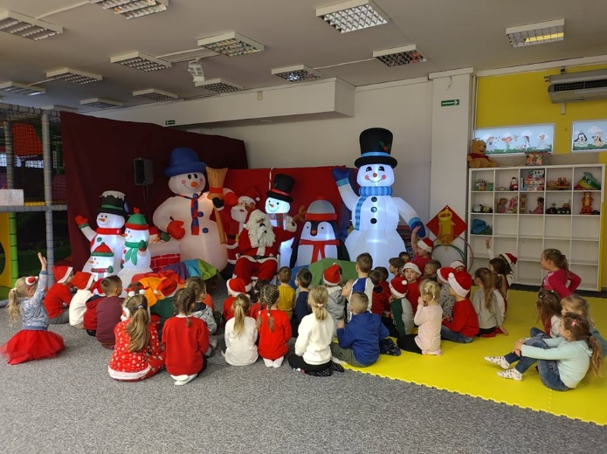

https://spborowa.edupage.org/album/#photos:album:1626
Rozwijanie talentów
KONKURS PLASTYCZNY –
"ŚWIĘTY MIKOŁAJ W OCZACH DZIECI"

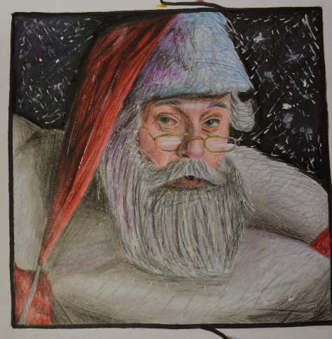
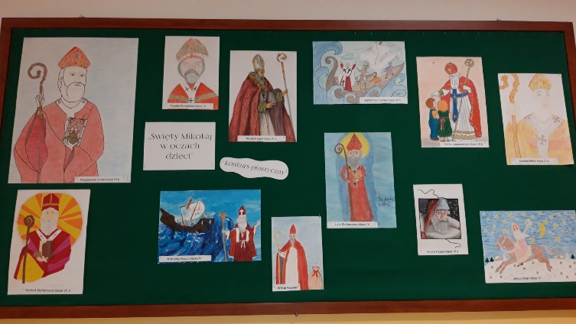

https://spborowa.edupage.org/album/#photos:album:1628

MIKOŁAJKI W VII A

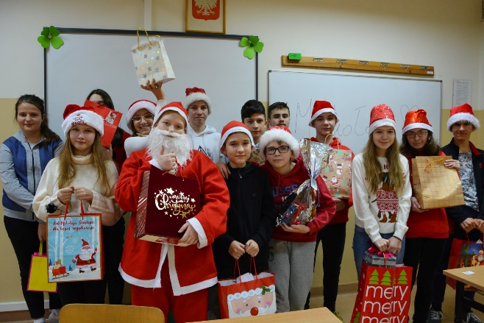
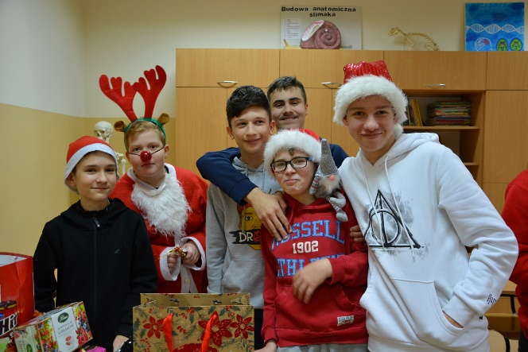

https://spborowa.edupage.org/album/#photos:album:1627

Promowanie zdrowego stylu życia
APETYCZNA LEKCJA

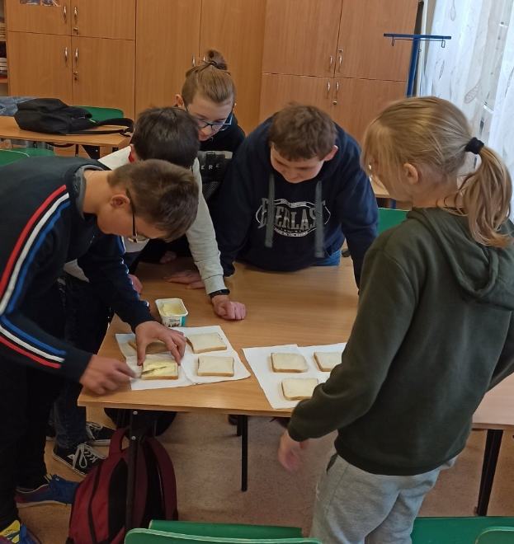
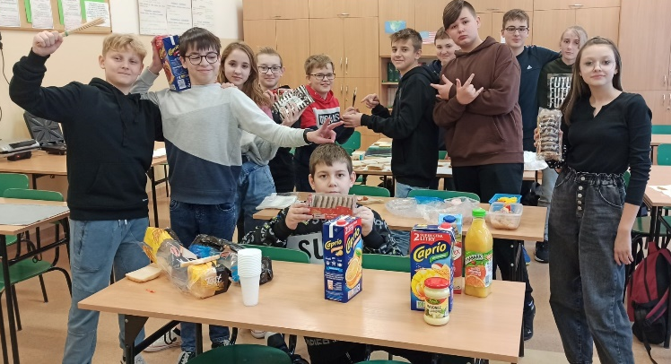

https://spborowa.edupage.org/album/#photos:album:1630
„ROZWIJAMY NASZE TALENTY PLASTYCZNE”

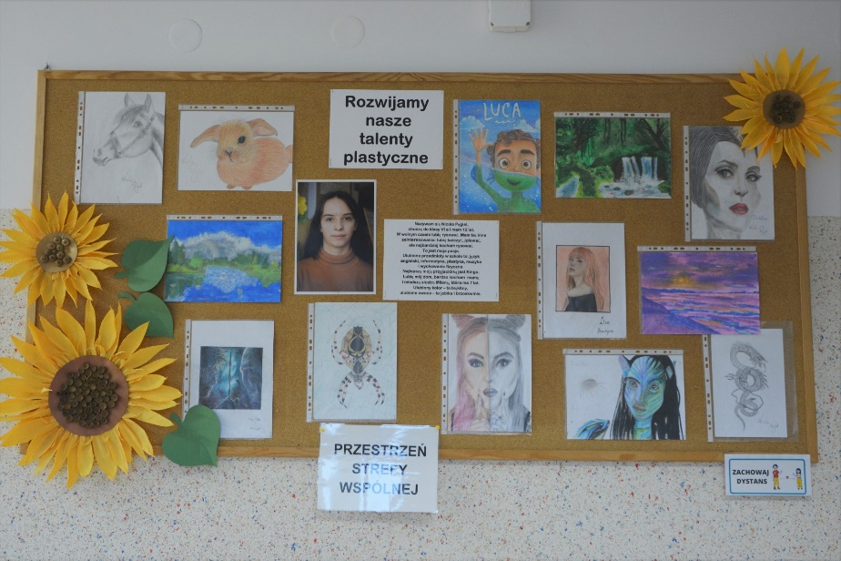

https://spborowa.edupage.org/news/?eqa=d2lkPW5ld3NfTmV3c18xX3AmbmV3c2FyY2hpdmVmPSZvZmZzZXRfbmV3c19OZXdzXzFfcD0w#photos:album:1631

Uwrażliwianie na piękno otataczającego świata
MAROKO – HISTORIA ZAKLĘTA
W KAMIENIU!

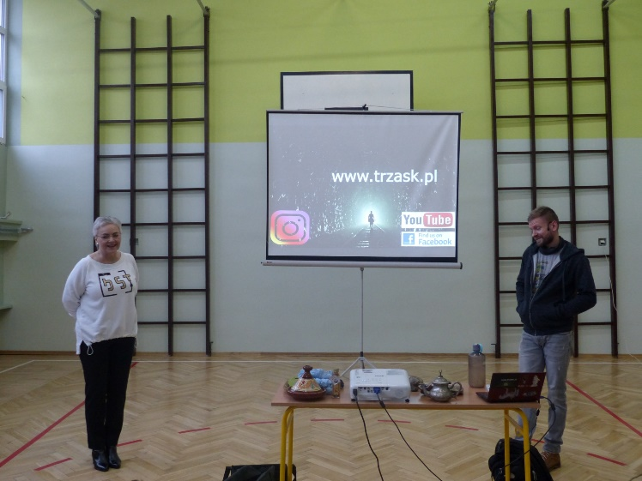
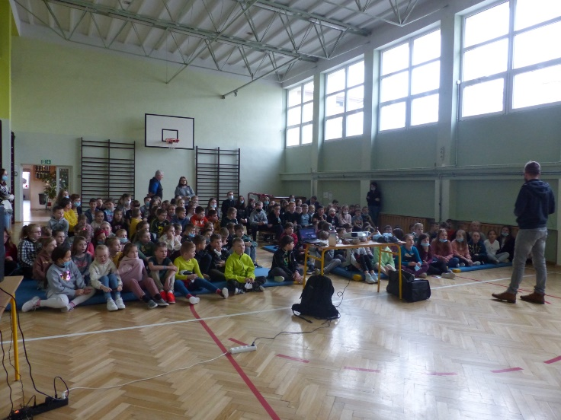

https://spborowa.edupage.org/news/?eqa=d2lkPW5ld3NfTmV3c18xX3AmbmV3c2FyY2hpdmVmPSZvZmZzZXRfbmV3c19OZXdzXzFfcD0w#photos:album:1632
Uczenie się przez doświadczenie
NIECODZIENNA LEKCJA
PT. „POCZUJ CHEMIĘ DO FIZYKI”

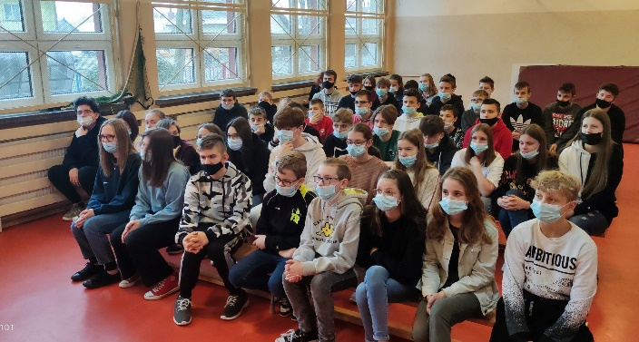
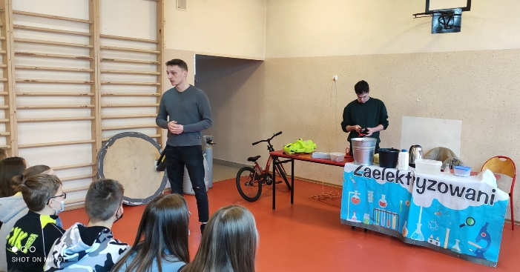

https://spborowa.edupage.org/news/#photos:album:1633
Rozwijanie zdolności artystycznych
SUKCES MŁODYCH AKTORÓW

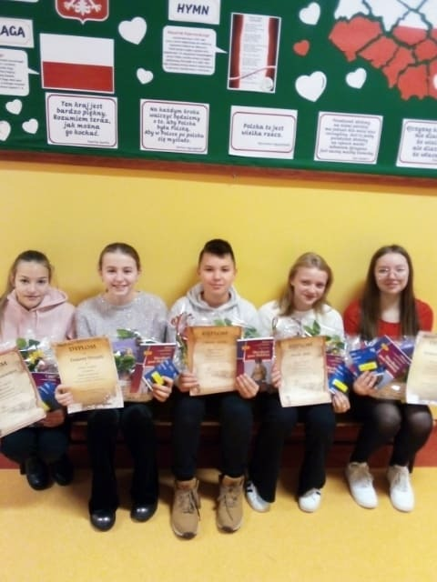
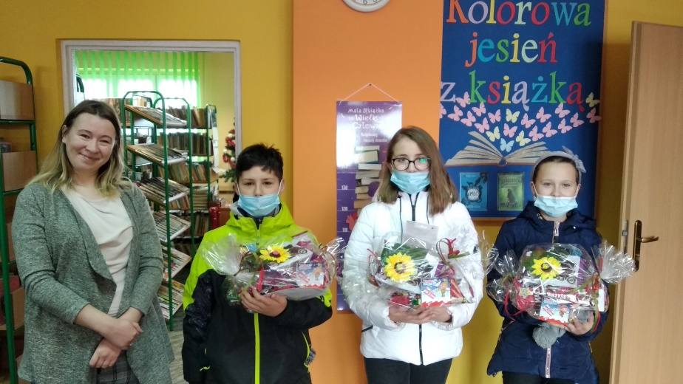

https://spborowa.edupage.org/news/#photos:album:1634
Kształtownie szacunku do tradycji
SZKOLNY QUIZ
,,CO WIESZ O ADAMIE MICKIEWICZU?”

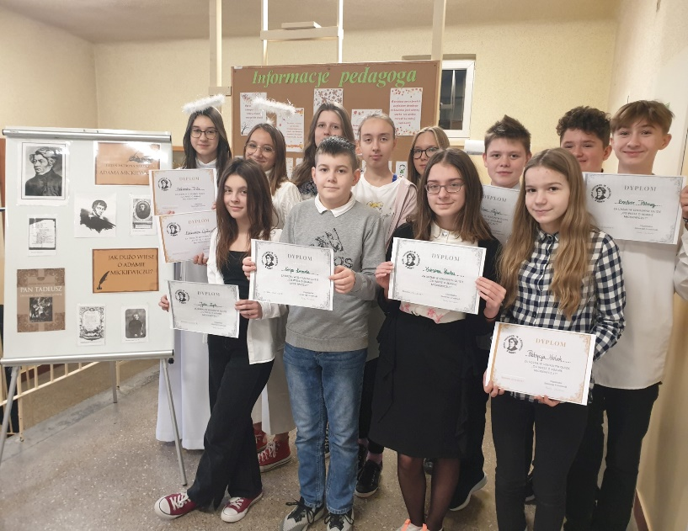

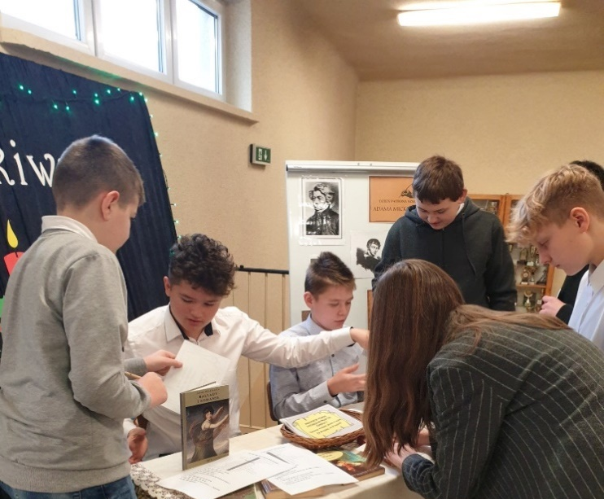

https://spborowa.edupage.org/news/#photos:album:1635

Budowanie systemu wartości
"KARTKI Z ISKIERKAMI EMOCJI"

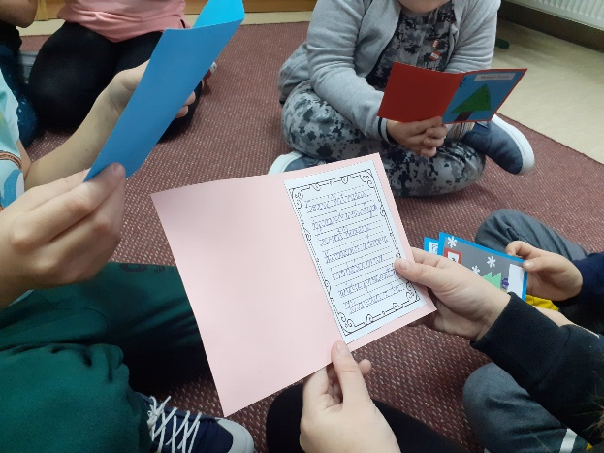

https://spborowa.edupage.org/album/#photos:album:1636
Promowanie czytelnictwa
NOWE LEKTURY CZEKAJĄ NA CZYTELNIKÓW!

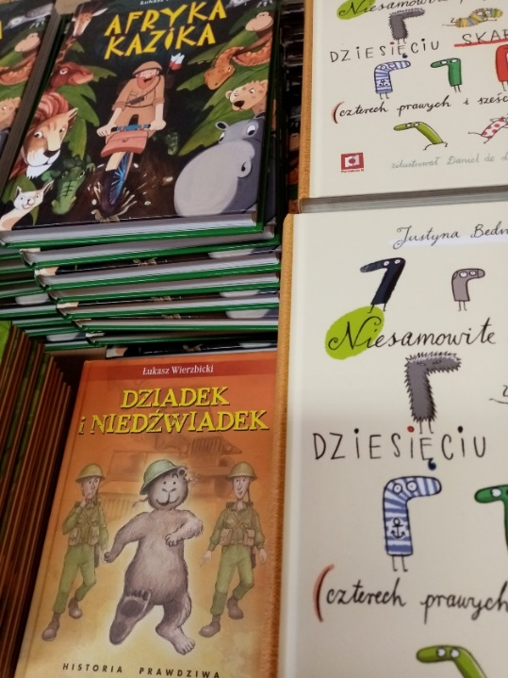
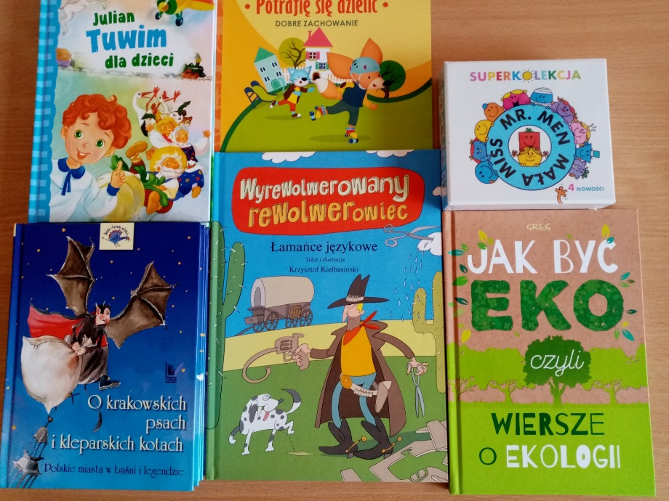

https://spborowa.edupage.org/news/?eqa=d2lkPW5ld3NfTmV3c18xX3AmbmV3c2FyY2hpdmVmPSZvZmZzZXRfbmV3c19OZXdzXzFfcD0w#photos:album:1646
Podtrzymywanie tradycji
OPŁATEK, ŚWIĄTECZNE ŻYCZENIA
I KOLĘDY W VII A
„SZTUKA POROZUMIEWANIA SIĘ”- ZAJĘCIA Z KOMUNIKACJI INTERPERSONALNEJ W KLASACH 4-6

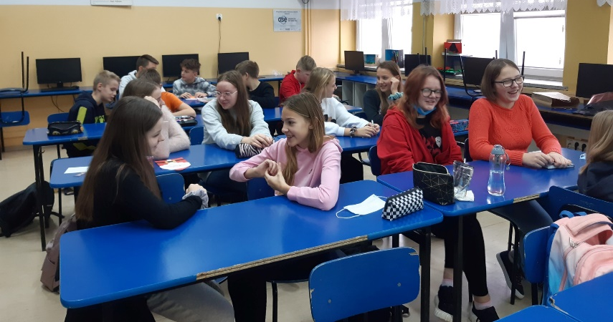
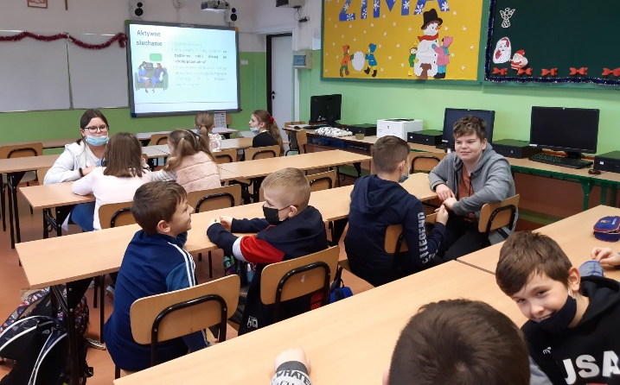

https://spborowa.edupage.org/news/?eqa=d2lkPW5ld3NfTmV3c18xX3AmbmV3c2FyY2hpdmVmPSZvZmZzZXRfbmV3c19OZXdzXzFfcD0w#photos:album:1641

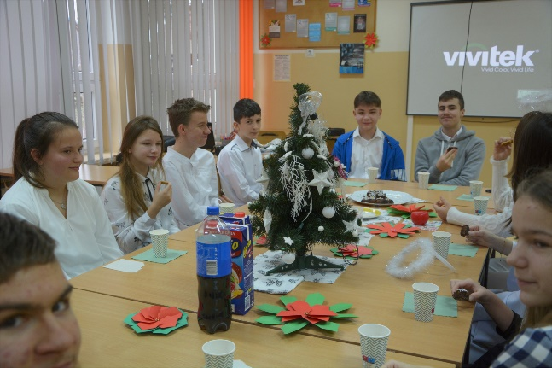
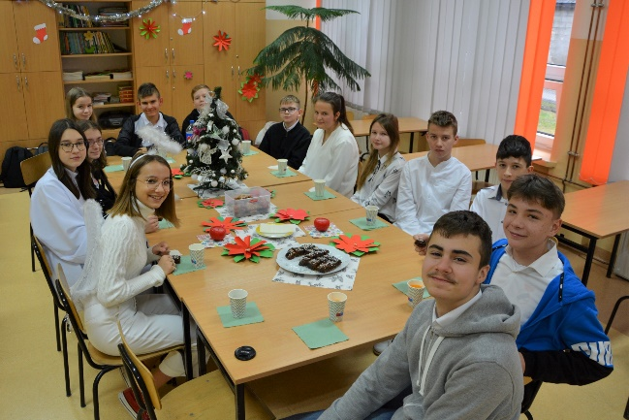

https://spborowa.edupage.org/album/#photos:album:1638

HEJ KOLĘDA, KOLĘDA!!!

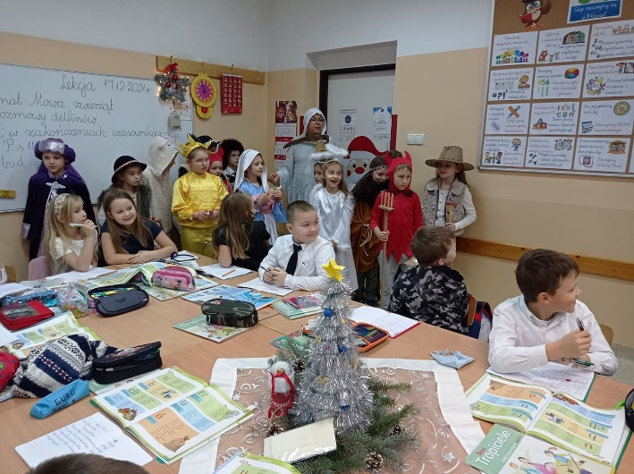
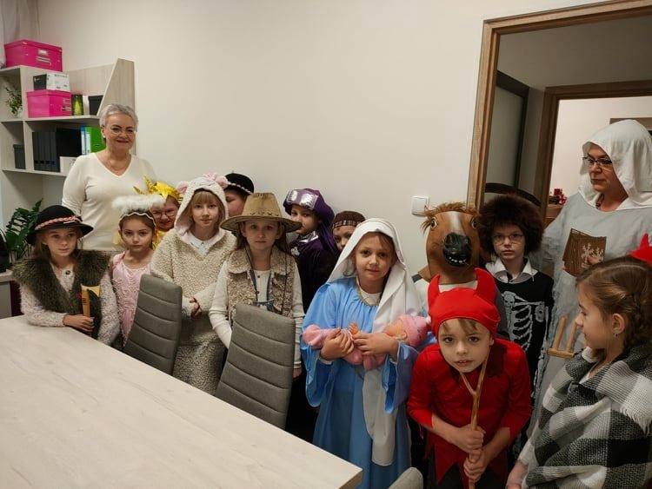

https://spborowa.edupage.org/album/#photos:album:1637

SZKOLNE KOLĘDOWANIE
Aktywizacja uczniów
KLASOWA WIGILIA W KLASIE VII B

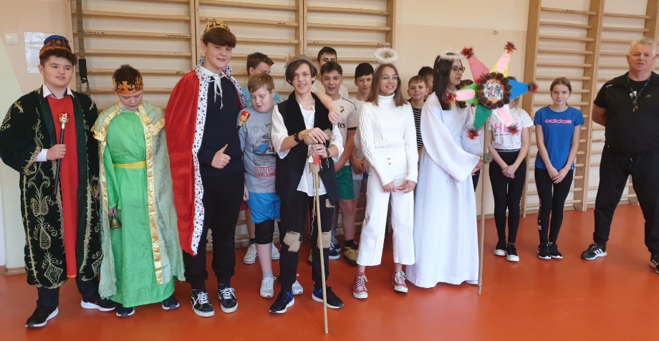
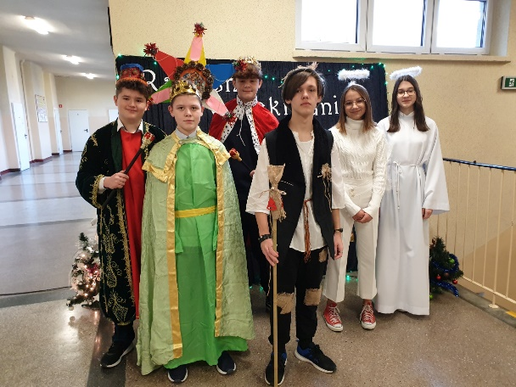

https://spborowa.edupage.org/album/#photos:album:1639

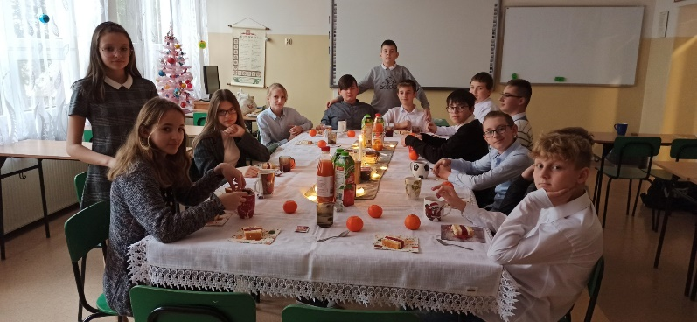
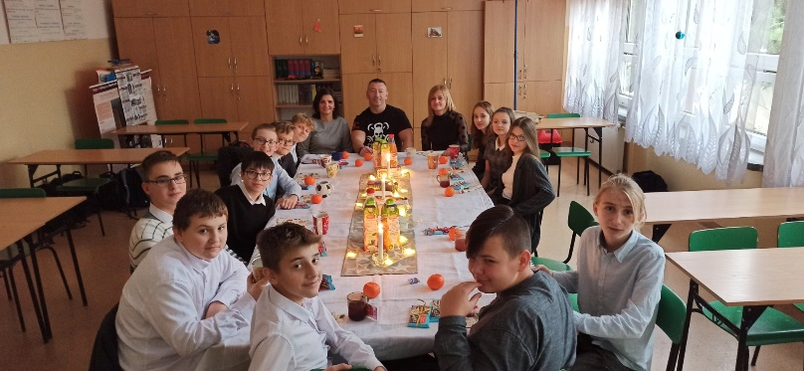

https://spborowa.edupage.org/news/?eqa=d2lkPW5ld3NfTmV3c18xX3AmbmV3c2FyY2hpdmVmPSZvZmZzZXRfbmV3c19OZXdzXzFfcD0w#photos:album:1640

Wskazywanie sposobów na życie pełne witalności
ZAKOŃCZENIE PROGRAMU SPORTOWO – PROFILAKTYCZNEGO „ ZDROWE ŻYCIE TO DŁUGIE ŻYCIE”

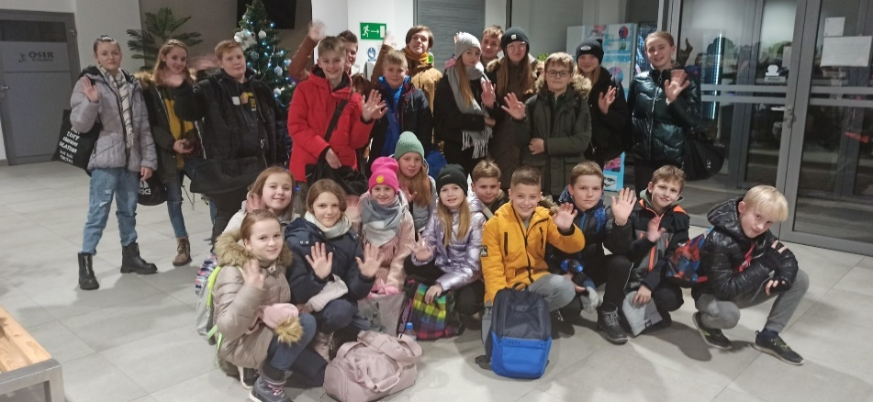

https://spborowa.edupage.org/news/?eqa=d2lkPW5ld3NfTmV3c18xX3AmbmV3c2FyY2hpdmVmPSZvZmZzZXRfbmV3c19OZXdzXzFfcD0w#photos:album:1644

Budowanie poczucia przynależności do małej ojczyzny GMINA BOROWA -
MOJA MAŁA OJCZYZNA

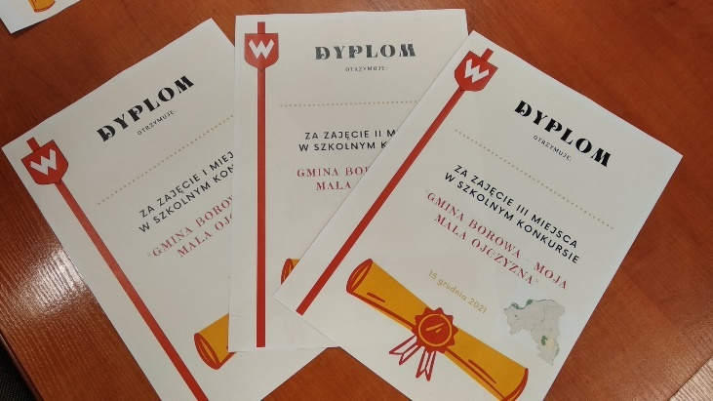
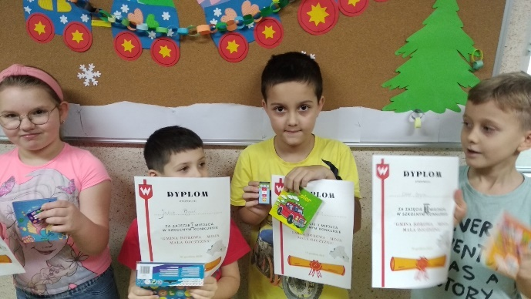

https://spborowa.edupage.org/album/#photos:album:1645

